**Documentation**

In this document I’m going to explaing how the applications works.

**Installation**

Steps to run the project successfully.

1. Be sure about the server that you are using un .env file 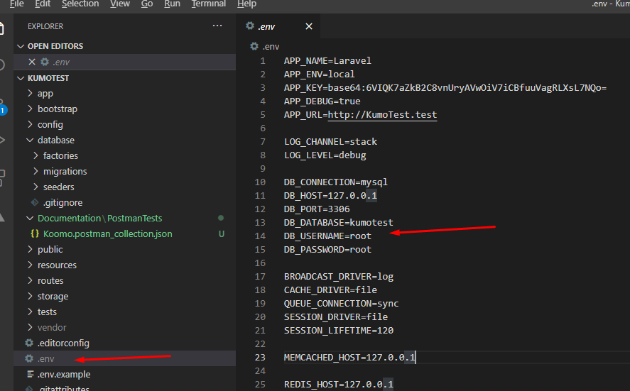
2. Use the command php artisan mirgrate:refresh to create/upload the tables that we are going to use.
3. Then Use the comman php artisan db:seed to creat some records (this step is not mandatory but it would be a good idea to test multiples records).

**A brief project introduction**

**Controllers**

The applicatión has 4 controllers one of them is a “baseController” that is just an extensión and it has standard methods that could be used in others.

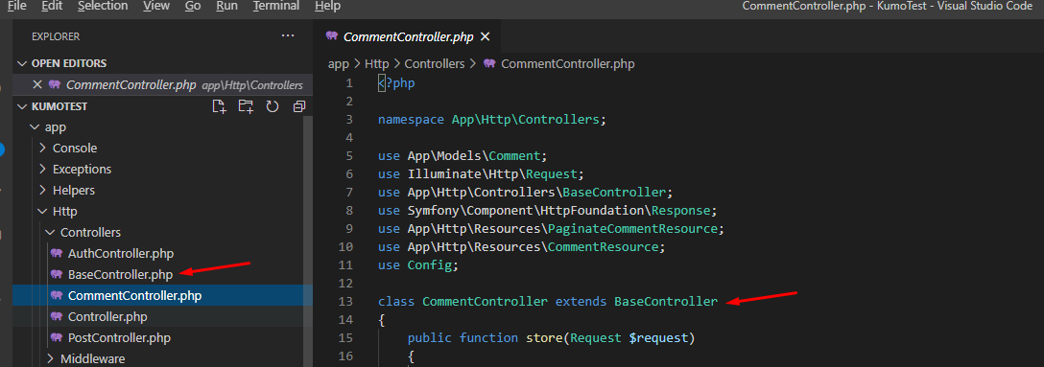

I made a method called “validateHeaders” which validate if the request has the correct headers, also it’ll send a 4** request when headers are incorrect.

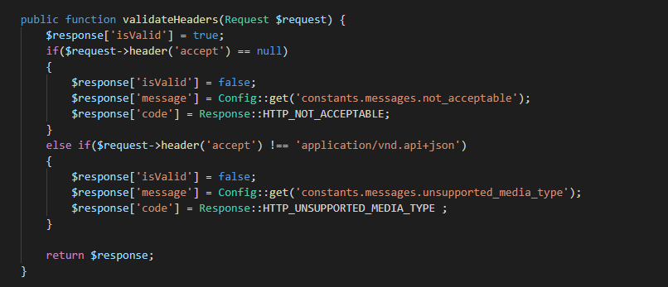

I had wrapped the code in try/catch to handler whole exceptions

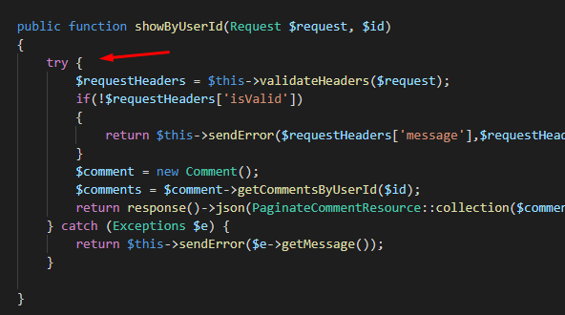

**Api.php**

I had wrapped the authenticated method in a middleware (using sanctum as middleware to auth)

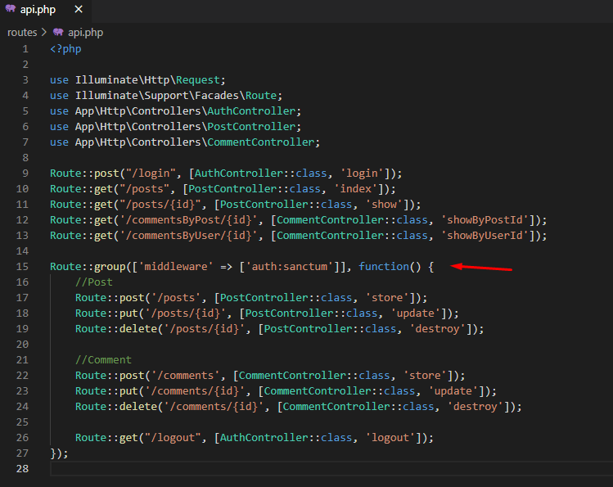

**Resources**

There are 5 resources files to map the data and throw Jsons in the right way (based in Json Api Documentation)

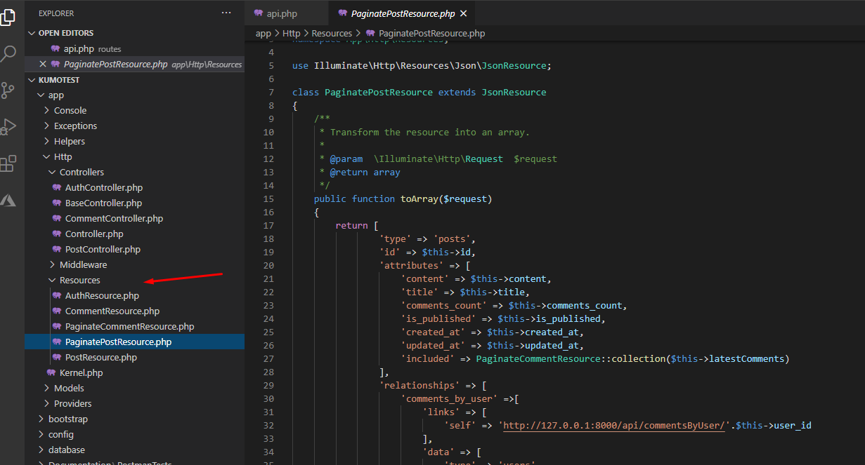

**CORS**

Cors are already enabled to use in a third-client party.

As you can see I can call my endpoints from another IP

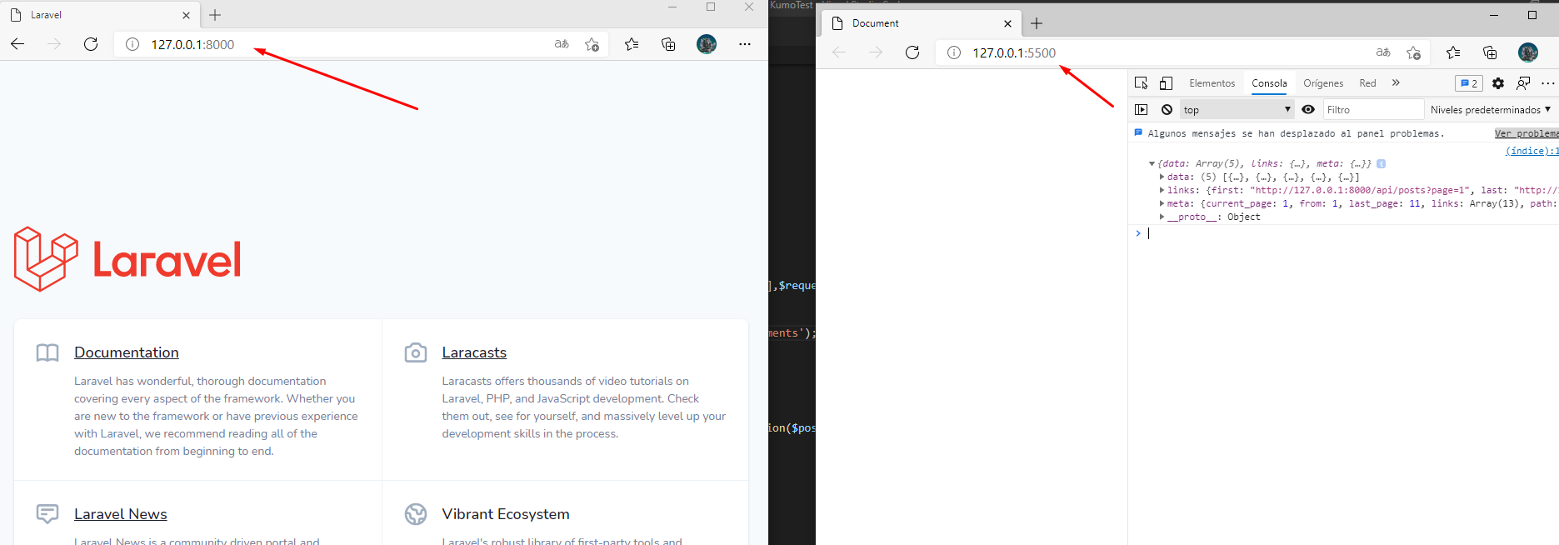

**Model**

I used the models just for make custom queries using eloquent and type the fields that are fillable.

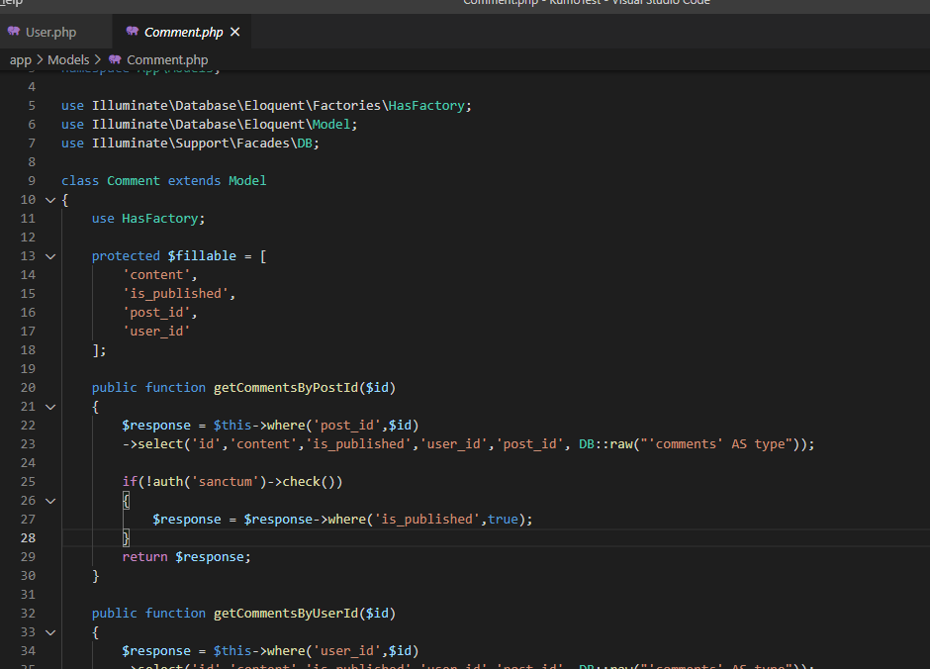

**Test**

I made a postman colletion, so you can test the differents endpoints just calling from Postman

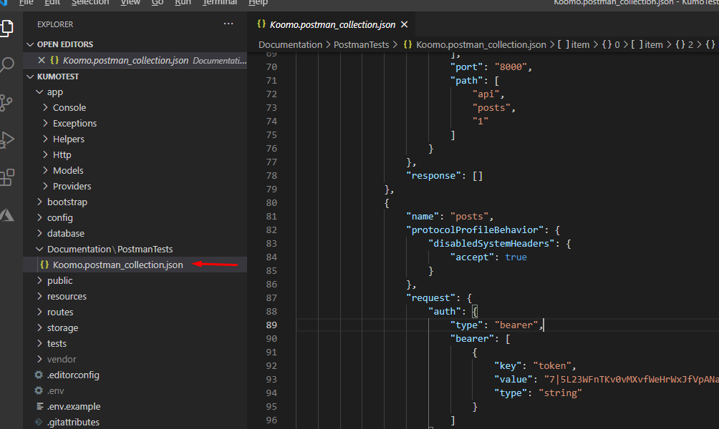

To test correctly the endpoints you must be logged and send the headers correctly.

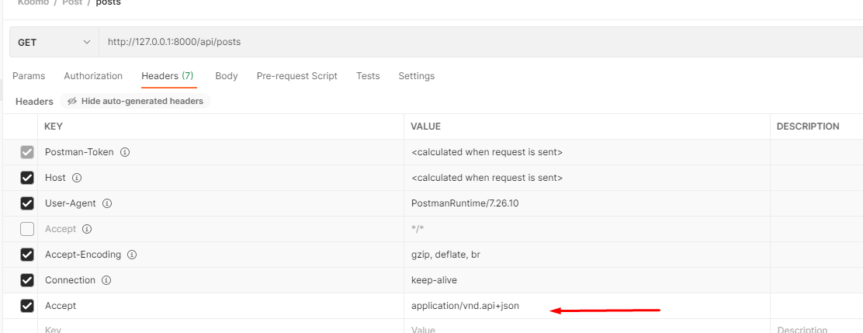

To get the user token you must use the login endpoint it will send you a token that you can use as an authentication bearer

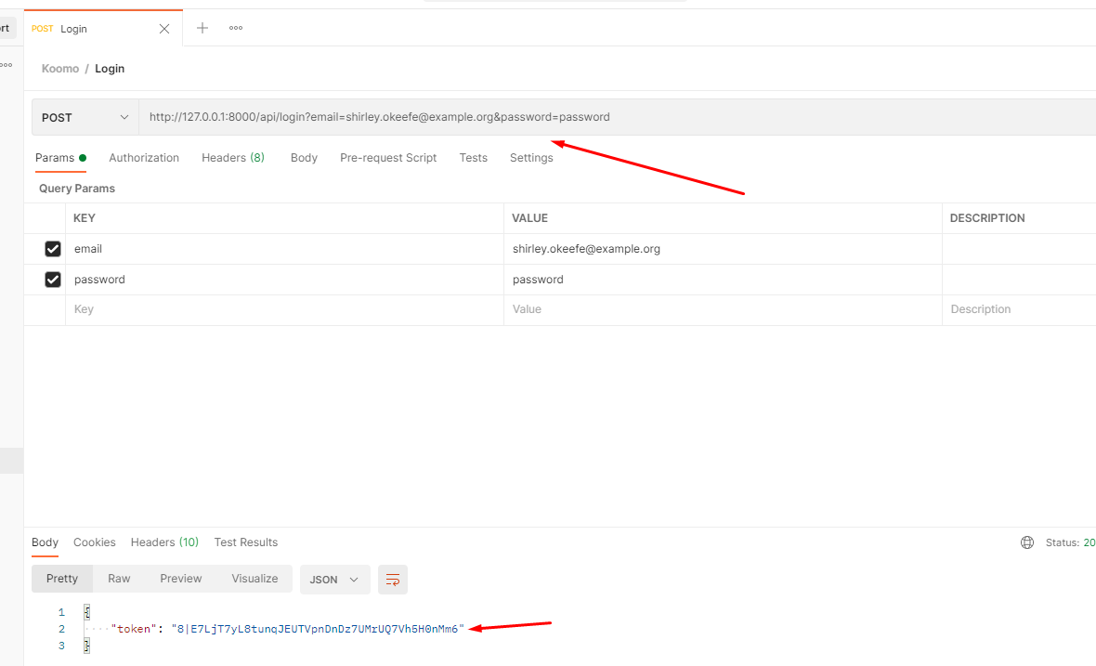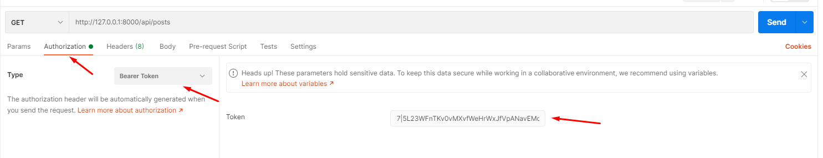

Finally to know which use you would use, you must take a look into the database and take one user (that method apply if you use the seed method to populate the database)

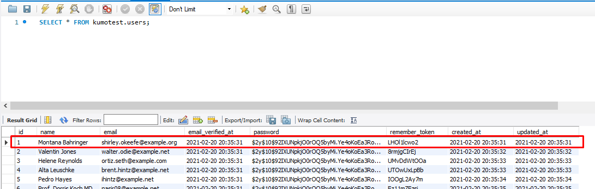

In case that you won’t use the seed method you can insert a user filling the columns, remember password column is an encrypted column based in SHA205 ($2y$10$92IXUNpkjO0rOQ5byMi.Ye4oKoEa3Ro9llC/.og/at2.uheWG/igi = “password”)